5/2/2025

Torin Flanagan 1169130

Engineering Project Management (ENG302)

Task 2 Project Plan A

Health Hub BIMS Dashboard For Stafford Projects

Contents

1. Project Background 3

1.1 Introduction 3

1.2 Project Goals and Objectives 3

1.3 SMART Goals 4

1.4 Project Deliverable 5

2. Project Planning Schedule 6

2.1 Work Breakdown Structure (WBS) 6

2.2 Limits and Exclusions 7

2.3 Time Management 8

2.3.1 PERT Time Estimates 8

2.3.2 Critical Path 8

2.3.3 Gantt Chart 9

3. Communication Management Plan 9

3.1 Stakeholder Analysis 9

3.2 Internal Communication Plan 11

3.3 External Communication Plan 12

4. Recommendations 14

5. References 14

6. Appendix 16

6.1 Gantt Chart (Appendix A) 16

## Figures and Tables

Figure 1: System architecture diagram of BIMS for health hub project 3

Figure 2: Initial mock-up of BIMS dashboard user interface 6

Figure 3: Two-pass flow chart displaying critical path, ES, EF, LS, LF, and floats 9

Table 1: Work breakdown structure including milestones and acceptance criteria 7

Table 2: PERT time estimates for BIMS dashboard project 8

Table 3: Communications strategy version control 9

Table 4: Internal stakeholder list 10

Table 5: External stakeholder list 10

Table 6: Internal information management plan 11

Table 7: External information management plan 12

## Project Background

### Introduction

On behalf of Academic Consultants, the project plan outlines the expected outcomes, scope, and key processes required for Stafford Projects and their health hub team. As outlined in the agreed project charter, the 8,000m², three-story facility adjacent to North Brisbane Hospital will incorporate a Building Information Management System (BIMS) dashboard. This supports Stafford Projects’ goals of environmental sustainability, showcasing commercial construction expertise, and achieving strong ROIs. BIMSs treat information as a corporate asset, enhancing transparency, accountability, and legal protection (Government of South Australia, 2022). With digital transformation accelerating, 65% of organisations report significant progress, up from 46% in 2018, while information management (20%) and governance (16%) emerge as key priority skills (AIIM, 2023).

### Project Goals and Objectives

Given the clear benefits alongside growing adoptions of BIMSs, it is evident as to why Stafford Projects should integrate such technology into the new health hub. This BIMS dashboard will comprise of three main layers; the user interaction layer (top), application layer (middle, and data layer (bottom).

Figure 1: System architecture diagram of BIMS for health hub project

### SMART Goals

1. **Energy Efficiency Optimisation**

* **S** – Enhance the health hub’s energy efficiency through integrating real-time monitoring of electricity and water use across the complex.
* **M** – Reduce total energy consumption by 15% within 12 months, compared to a similar sized commercial building. The industry average was found to be ~242.18 kWh/m²/year (Industry Insights, 2021), serving as a reference point.
* **A** – IoT-enabled meters and sensors will be used to detect inefficiencies in HVAC, lighting, water, and other related systems.
* **R** – A goal such as this aligns with Stafford Projects’ mission while also reducing operational costs.
* **T** – Successful implementation and monitoring should be completed within the first year of operation.

1. **Office and Parking Space Utilisation Enhancement**

* **S** – Enhance office and parking space by using occupancy tracking and booking systems across the 30 offices and bottom floor carpark.
* **M** – Achieve and maintain an average occupancy rate of 80% within the first 6 months of the health hub’s launch.
* **A** – Use of sensor data from the BIMS dashboard, identifying underused spaces and improving tenant allocations alongside carpark efficiency.
* **R** – Aligns with Stafford Projects’ goal of maximising rental income, commercial viability, and transport sustainability.
* **T** – BIMS dashboard functionality should be fully operational within 2-3 months of the project’s completion.

1. **Real-Time Safety Monitoring**

* **S** – Enhanced safety monitoring due to real-time incident logs and hazard alerts via use of the BIMS dashboard.
* **M** – Achieve a 100% hazard response logging rate within 5-10 minutes of detection or reporting.
* **A** – Enable automated alerts via using sensors and manual reporting tools.
* **R** – Supports health and safety compliance in the medical sector, supporting Stafford Projects’ reputation for quality.
* **T** – Will be fully integrated with the BIMS dashboard post-construction.

1. **Predictive Maintenance Management**

* **S** - Improve maintenance efficiency through automated alerts via BIMS dashboard.
* **M** – Reduce unplanned maintenance by 25% within the first year of operations.
* **A** – Use of predictive maintenance algorithms linked with monitoring systems via BIMS dashboard access.
* **R** – Ensures tenant satisfaction and minimises downtime of critical systems.
* **T** – Predictive maintenance tools implemented within two months of building operations.

1. **Performance Reporting For Sales And Leasing Decisions**

* **S** – Enable real-time access to energy, space, and maintenance reports to support sales and leasing decision-making.
* **M** – Generate monthly performance reports for potential buyers and/or tenants.
* **A** – Use of BIMS dashboard with cloud integration to compile and export visual and numerical data.
* **R** – Demonstrates building efficiency and profitability, aiding Stafford Projects’ long-term investment and commercial goals.
* **T** – Performance report features will be implemented and used within the first quarter of the health hub opening.

### 1.4 Project Deliverable

The primary outcome of this project is the successful development and implementation of a BIMS dashboard for Stafford Projects’ health hub, becoming further enhanced. This centralised digital platform will improve operational efficiency, sustainability, safety, and commercial outcomes. Aligned with the SMART goals and strategic objectives outlined earlier, the completed BIMS project will deliver these key deliverables:

* Fully functional, user-friendly dashboard accessible only to authorised users.
* Real-time monitoring of electricity and water usage, with custom dashboards benchmarked against industry standards.
* A booking system with real-time analytics to optimise office and carpark occupancy.
* Integrated safety features including real-time incident logging, sensor-based hazard detection, manual reporting, and automated alerts.
* Predictive maintenance tools for alerts, maintenance history tracking, and task scheduling.
* Sales and leasing tools for monthly performance reporting using visual and numerical data.
* Comprehensive staff training and documentation.
* A post-implementation review assessing performance, outcomes, lessons learned, recommendations, and formal handover to Stafford Projects.

Below is an initial interface concept for the BIMS dashboard, showing subsystem navigation (e.g. Health Hub Core Building Usages) after user login:

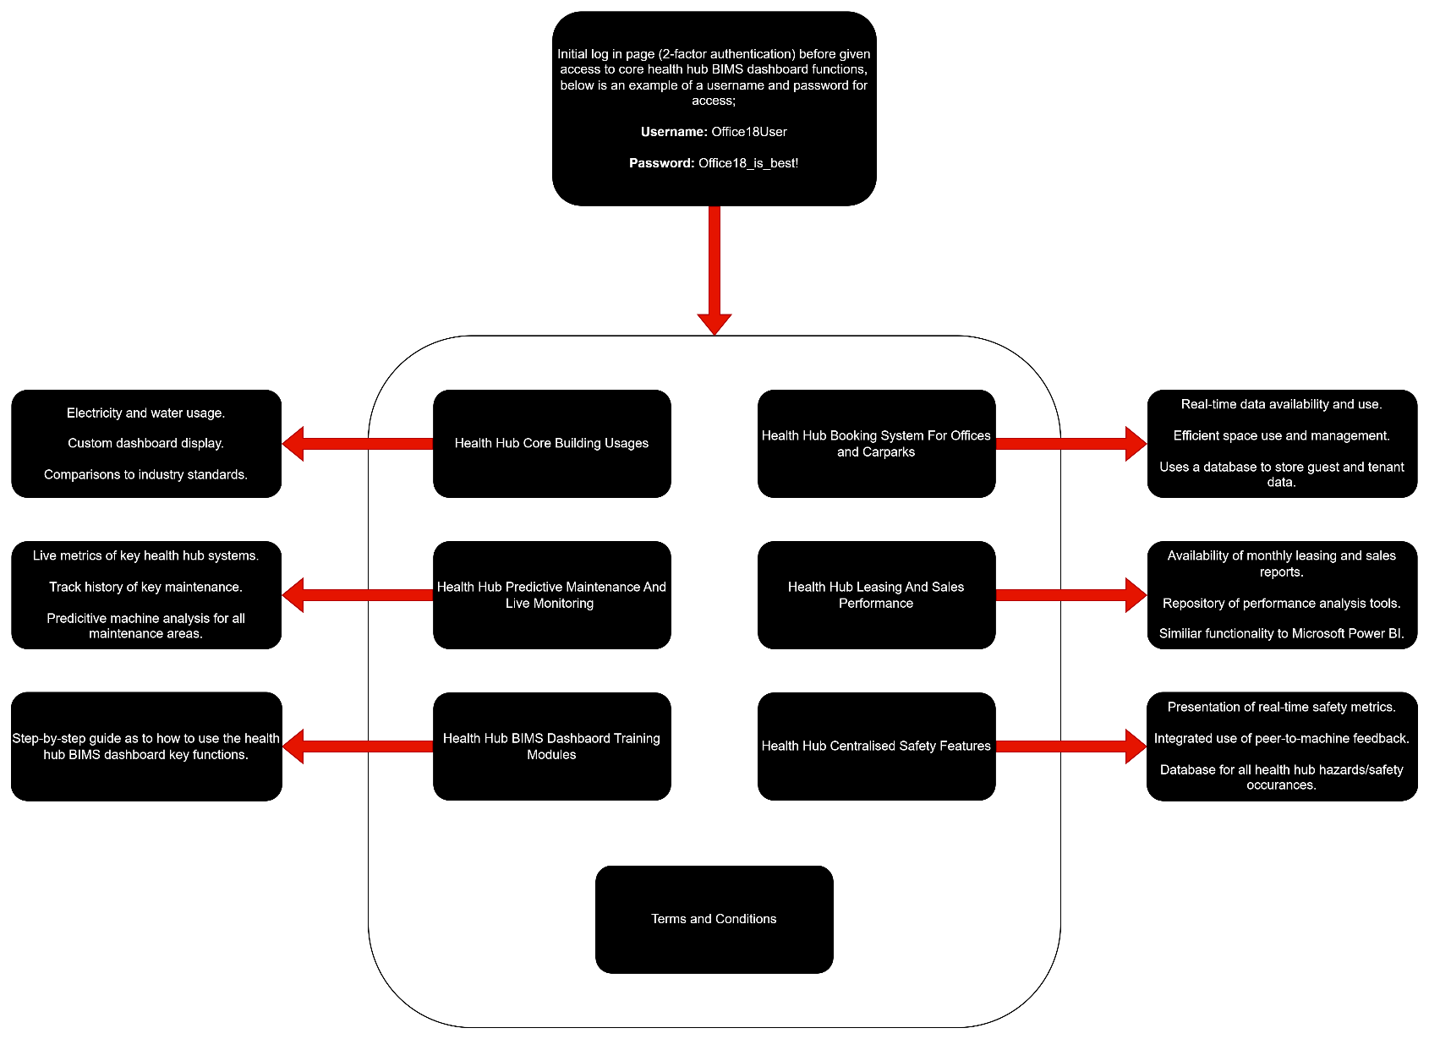Figure 2: Initial mock-up of BIMS dashboard user interface

## Project Planning Schedule

### 2.1 Work Breakdown Structure (WBS)

Table 1 presents the WBS, outlining the 10 work packages and their associated activities required to complete the project deliverables. Project milestones are clearly marked with red-filled boxes, indicating actions needed to progress to the next work package. Milestones will be validated by the CEO (Chris Jones), sponsor (Stafford Projects), and project manager (Jim Murdoch), in line with the acceptance criteria. Some milestones may also require approval from key stakeholders, contractors, or industry and financial inspectors.

Table 1: Work breakdown structure including milestones and acceptance criteria

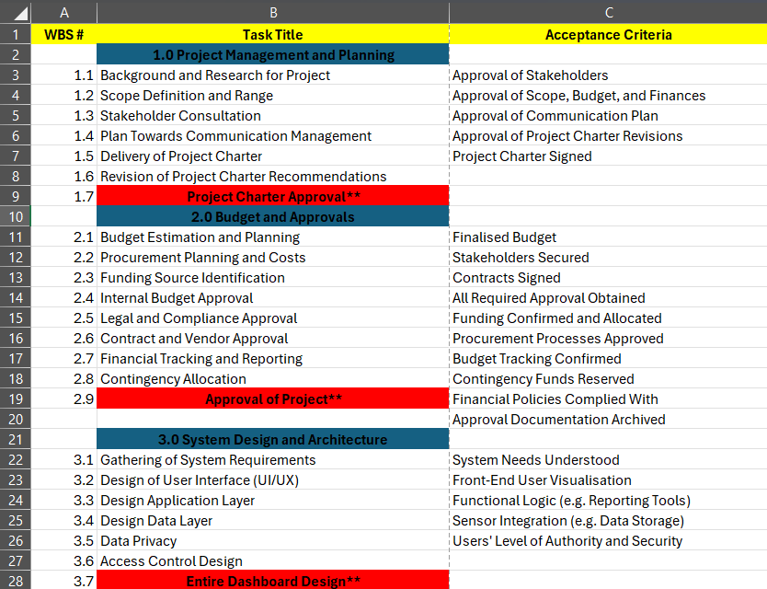

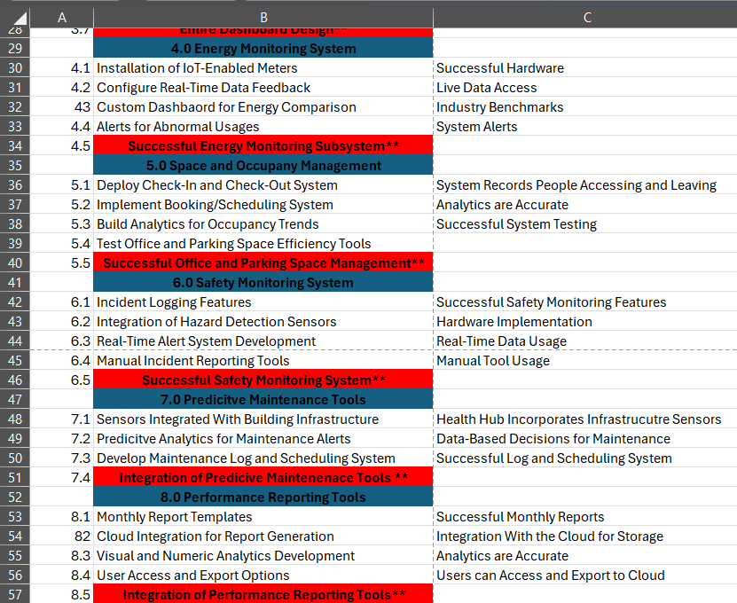

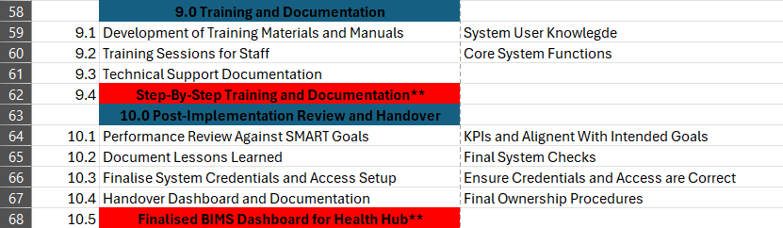

### 2.2 Limits and Exclusions

Defined limits and exclusion are used to ensure clarity and manage expectations. Hardware procurement is limited to integrating existing IoT and sensor devices; major infrastructure upgrades (e.g. electrical systems) must be separately funded. While handover and system documentation are included, ongoing support, maintenance, and upgrades post-handover are excluded. Only core dashboard functionalities are in the scope; custom features require formal change requests. Training is provided for designated staff roles, with future onboarding of new personnel becoming Stafford Projects’ responsibility. Lastly, the dashboard will be developed solely as a web-based interface, with mobile app development excluded from the scope.

### 2.3 Time Management

### 2.3.1 PERT Time Estimates

The PERT time estimates table (in days) suggests the BIMS dashboard project will take approximately 199.83 days, rounded to 200. Provided all activities follow the scheduled sequence without delays, the project is expected to meet this timeline. These estimates will also inform the critical path analysis in section 2.3.2

Table 2: PERT time estimates for BIMS dashboard project

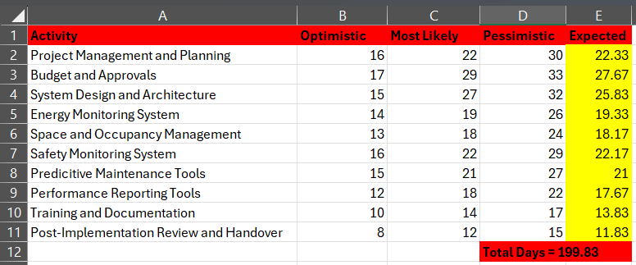

### 2.3.2 Critical Path

The critical path was determined using the two-pass methods, based on time estimates from the PERT table. Represented by orange arrows, the critical path follows stages 1.0, 2.0, 3.0, 4.0, 6.0, 7.0, 9.0, 10.0. Stages 5.0 and 8.0 have float values, indicating flexible start dates. This highlights that space and occupancy features, along with performance reporting, are less critical than core components like energy consumption and other systems.

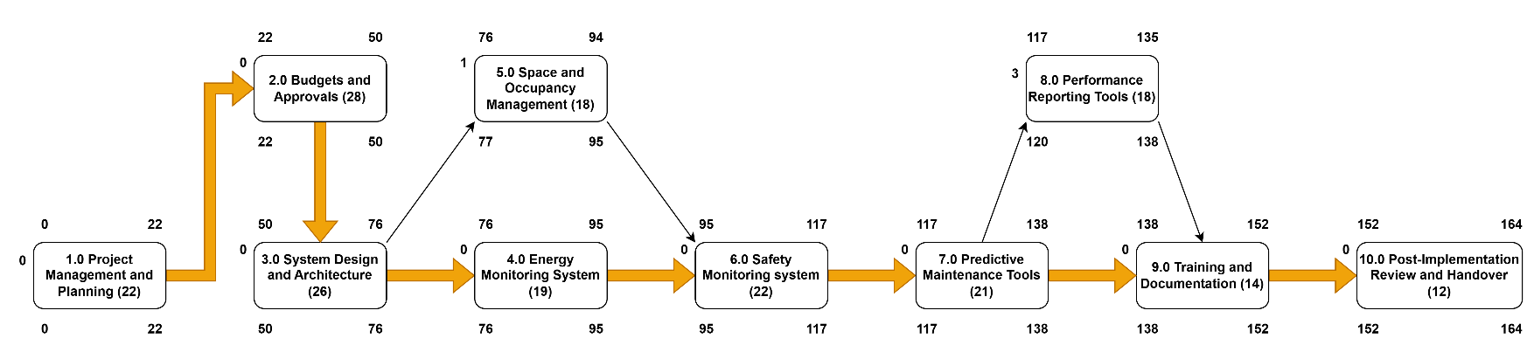Figure 3: Two-pass flow chart displaying critical path, ES, EF, LS, LF, and floats

### 2.3.3 Gantt Chart

The final project planning tool used a Gantt chart, outlining each high-level work package and its sub-activities. This chart enables detailed scheduling and highlights concurrent tasks, reducing the estimated project duration from 200 to 142 days.

The Gantt Chart, located in Appendix A, is divided into 3 phases; Pre, During, and Post. Solid arrows indicate finish-to-start dependencies, while dotted arrows represent lag times (e.g. revising project charter recommendations before final approval).

## Communication Management Plan

**Project Information:**

The BIMS dashboard health hub project is a 142-day project initiative to deliver a centralised information management system, featuring energy, space, occupancy, and safety monitoring, predictive maintenance, and performance reporting tools.

Table 3: Communications strategy version control

|  |  |  |  |
| --- | --- | --- | --- |
| **Version** | **Date** | **Author** | **Change Description** |
| 1.0 | 27/04/2025 | Torin Flanagan | Initial draft of communications strategy |
| 2.0 | TBD | TBD | TBD |

### 3.1 Stakeholder Analysis

**Purpose of Communication Strategy:**

Communicate progress on the Stafford Projects’ health hub BIMS dashboard to the below internal and external stakeholders:

Table 4: Internal stakeholder list

|  |  |  |
| --- | --- | --- |
| **Internal Stakeholders** | **Why** | **Communication Methods** |
| Chris Jones (CEO) | Project sponsor who provides overall strategic direction and approvals | Executive summaries, progress reports, and strategy meetings |
| Jim Murdoch (project manager) | Oversees project execution, schedules, resources, and risk management | Regular team meetings, project management tools, and email updates |
| Jill Luppi (contract administrator) | Handles procurement, contracts, legal approvals, etc | Emails, contracts, and procurement meetings |
| Peter Smith (project administrator) | Supports scheduling, documentation, reporting, etc | Scheduling tools, emails, and documentation (reports, and meeting notes) |
| Lance Wilson (site foreman) | Manages on-site installations (e.g. IoT meters, sensors, etc) | Daily briefings, site visits, phone calls, and project management tools |
| Sam Owens (safety officer) | Ensures system meets workplace safety requirements and manages safety monitoring features | Weekly check-ins, email updates, and safety meetings. |
| Janette Tobeck (office manager) | Assists with logistics, internal communication, space management input, etc. | Emails, internal communication platforms (e.g. MS Teams) and team meetings. |
| ICT/IT department | Supports integration, server/cloud setups, cybersecurity, etc. | Technical meetings, emails, issue tracking systems, and internal documentation. |
| Building facilities management team | Day-to-day users of the dashboard for monitoring systems and maintenance planning. | Weekly meetings, internal communication platforms, dashboard access, and training. |
| Finance department | Track the project budget and ongoing cost savings from system efficiencies. | Monthly budget reports, financial tracking tools, and project updates. |
| Staff and employees (general users) | Feedback helps refine dashboard usability features. | User training sessions, newsletters, email updates, and surveys. |

Table 5: External stakeholder list

|  |  |  |
| --- | --- | --- |
| **External Stakeholders** | **Why** | **Communication Methods** |
| Health hub building users (e.g. staff and tenants) | They interact with the building | Workshops, emails, user guides, newsletters, and online posts |
| Vendors and suppliers | Provide IoT devices, hazard sensors, predictive maintenance technology, etc | Email updates, phone calls, meetings, and project management tools |
| Contractors | Installation of IoT meters, safety sensors, IT infrastructure, etc | Scheduled meetings, sites visits, phone calls, and project management tools |
| External funding bodies | Interested in project delivery, compliance, and value for money | Formal reports, executive summaries, presentations, and financial documents |
| Regulatory agencies | Ensures legal, compliance, safety, and data protection standards are met | Formal documentation (compliance reports), official letters, and audits |
| Local council and authorities | Needed when building compliance or public safety is necessary | Formal letters, compliance reports, and meetings (if needed) |
| End-users (e.g. visitors and customers) | Benefit from improved building safety and occupancy management indirectly | Digital signage, informational brochures, and website updates |

**Formal Written Communication Methods:**

Formal methods such as reports, emails, and official letters ensure clear, traceable records of decisions and project updates. These are essential for accountability and future reference towards managing the health hub BIMS Dashboard (Swafford, 2024).

**Interactive Communication Methods:**

Verbal methods like phone calls and meetings allow real-time feedback, clarify stakeholder needs, and support effective coordination, especially with external parties like contractors and suppliers (Palmer, 2021).

**Digital Communication Tool Methods:**

Digital platforms streamline collaboration, enable quick responses to changes, and support informed, data-driven decisions throughout the project lifecycle (Afridi et al., 2023).

### 3.2 Internal Communication Plan

Table 6: Internal information management plan

|  |  |  |  |  |
| --- | --- | --- | --- | --- |
| **Medium** | **Activity** | **Responsibility** | **Frequency** | **Comment** |
| File storage and collaboration (e.g. SharePoint) | Document management and storage | PO | Continuous | * Version control * Collaborative editing * Document access |
| Internal chats (e.g. MS Teams) | Short notice updates and coordination | All relevant team members | Daily | * Internal updates * Clarifying * Informal communication |
| Project meetings | Progress updates and task planning | Project manager | Weekly | * Align schedules * Raise concerns * Review progress |
| Email | Formal communication and updates | All relevant stakeholders | Continuous (when needed) | * Distribute reports * Share decisions * Major announcements |
| Project management tools (e.g. Monday.com) | Tracking of tasks and status updates | Project administrator | Daily | * Visualise deadlines * Understand responsibilities * Display dependencies |
| Register for risks (e.g. spreadsheets) | Log and monitor risks | Safety officer and project manager | Weekly | * Risk likelihood * Impact from risk * Mitigation strategies |
| Budget tracking sheet (Excel) | Monitoring and reporting of finance | Finance department | Weekly | * Record and analyse spendings * Future costs |
| Dashboard feedback form | Staff usability feedback | Admin and system users | Fortnightly | * Refine user experience * Ensure user satisfaction |

**Internal Communications Activity Phase Summaries:**

* File storage and collaboration:
  + Phase 1; setting up folders for project documentation and version control.
  + Phase 2; continued use for storing documented updates, meeting notes, and stakeholder feedback.
* Internal chats:
  + Phase 1; specifying team channels and coordination use in line with project initiation.
  + Phase 2; ongoing use regarding day-to-day discussions, responsibilities, and file-sharing.
* Project meetings:
  + Phase 1; kick-off meeting followed with weekly sessions to confirm project goals and objectives.
  + Phase 2; weekly check-ins correlating with overall progress, addressed issues, and overall reporting.
* Email:
  + Phase 1; official introductions, schedules, and initial documentations.
  + Phase 2; share scheduled activities, formally share updates, and communicate summary reports.
* Project management tools:
  + Phase 1; created task lists, responsibilities assigned, and expected project timeline.
  + Phase 2; updates for task progress, delays tracked, and adjusted timelines.
* Register for risks:
  + Phase 1; initial documented, reviewed, and shared risks.
  + Phase 2; updates of risk likelihoods and impact, alongside added risks from project progress.
* Budget tracking sheet:
  + Phase 1; allocate budget forecast and collaborations with finance.
  + Phase 2; updates from actual spendings occurring, reviewed regularly according to finance updates.
* Dashboard feedback form:
  + Phase 1; internal users create and trial dashboard layout
  + Phase 2; feedback collected from dashboard users, then integrated into design considerations.

### 3.3 External Communication Plan

Table 7: External information management plan

|  |  |  |  |  |
| --- | --- | --- | --- | --- |
| **Medium** | **Activity** | **Responsibility** | **Frequency** | **Comment** |
| Email | Share project updates, documentation, and action items with stakeholders | Project manager | Daily to weekly | Primary methods towards communication with vendors, funders, and agencies |
| Workshops | Engage building users and tenants for feedback and user requirements | Office manager | After key project phases | Essential for aligning dashboard features with user needs |
| Formal reports | Compliance, financial, and milestone updates | Project manager and compliance officer | Weekly | Standard process to communicate with funding bodies, insurers, and regulatory agencies |
| Phone calls/video calls | Discuss time-sensitive issues and clarify technical requirements | Project manager and site leads | Daily | Useful during supplier coordination and on-site changes |
| Project management tools | Share tasks, documents, and progress milestones with contractors/vendors | Project manager and admin team | Daily | Limited access with external parties for visibility and coordination |
| Formal letters | Notify councils, regulatory bodies, or insurers of key decisions or incidents | Compliance officer | When necessary | Maintains legal and professions record of communication |
| Executive summaries | Communicate project status to funding bodies and senior external stakeholders | Project manager and CEO | After major milestones | Condensed view of achievements, delays, and financial summaries |
| Site visits | Conduct walk-throughs, inspections, or collaborative planning on-site | Site foreman and project manager | After key project phases | Important for physical validation of installation and equipment |

**External Communications Activity Phase Summaries:**

* Email:
  + Phase 1; introduce project to external stakeholders.
  + Phase 2; continue updates, coordination, document sharing, and responses to stakeholders.
* Workshops:
  + Phase 1; initial consultations held with building users for understanding usage and expectations.
  + Phase 2; follow-up workshops conducted for prototype concepts and feedback collection.
* Formal reports:
  + Phase 1; intended project scope and timeline shared with required stakeholders.
  + Phase 2; progress and compliance reports distributed, maintaining transparency.
* Phone calls/video calls:
  + Phase 1; coordinated vendor, contractor onboardings, and site readiness discussions.
  + Phase 2; manage installation progress, resolve issues, and clarify deliverables.
* Project management tools:
  + Phase 1; limited access to stakeholders for task visibility and schedule alignments.
  + Phase 2; shared updates and documented collaborations.
* Formal letters:
  + Phase 1; outline project intent and compliance approach.
  + Phase 2; confirm compliance approvals, notify milestones, and request final clearances.
* Executive summaries:
  + Phase 1; top-level stakeholders outline the key deliverables.
  + Phase 2; updated versions after each milestone or project scope change.
* Site visits:
  + Phase 1; site walk-throughs for required stakeholders during planning.
  + Phase 2; scheduled inspections during installation and pre-testing phases.

## Recommendations

A strong understanding of time management within the project plan enables work package activities of the same task type to run concurrently, provided dependencies allow (e.g. finish-to-start logic). For example, in the ‘energy monitoring system’ work package, real-time data feedback can’t begin until all IoT-enabled meters are installed. However, during meter installation, tasks such as developing the custom dashboard for comparing energy usage and configuring abnormal usage alerts can proceed parallel of each other.

To ensure project alignment and milestone validation, site visits, meetings, and workshops should occur before transitioning to the next project phase. This ensures all key stakeholders agree on the progress and that each success criteria is met.

Effective communication between internal and external stakeholders is essential. Each stakeholder group should be engaged using communication methods suited to their roles and involvements.

Ultimately, by aligning project deliverables, scheduling, and communication planning, the health hub BIMS dashboard will meet the needs of stakeholders, investors, users, and other key parties.

## References

* Afridi, K., Turi, J. A., Zaufishan, B., & Rosak-Szyrocka, J. (2023). Impact of Digital Communications on Project Efficiency through Ease of Use and Top Management Support. Heliyon, 9(7), e17941. https://doi.org/10.1016/j.heliyon.2023.e17941
* AIIM. (2023). AIIM 2023 State of the Intelligent Information Management Industry: In Partnership with Pivotal Moment in Information Management. In RIMPA Global (p. 45). file:///C:/Users/torin/Downloads/AIIM-2023-Survey-Results-State-of-the-Intelligent-Information-Management-Industry%20(3).pdf
* Government of South Australia. (2022, September 28). Benefits of Managing Information. State Records of South Australia. https://www.archives.sa.gov.au/managing-information/Information-management/benefits-of-managing-information
* Industry Insights. (2021, January 7). Benchmarking commercial energy use per square foot. Twinview. https://www.twinview.com/insights/benchmarking-commercial-energy-use-per-square-foot
* Palmer, K. (2021, July 14). Communication techniques for effective project management. https://www.apm.org.uk/blog/communication-techniques-for-effective-project-management/
* Swafford, Z. (2024, July 26). Why Is Communication Important in Project Management? Master the Art of Clear Dialogue. https://www.itsdart.com/blog/why-is-communication-important-in-project-management#:~:text=Written%20Communication%20in%20Project%20Management&text=It%20provides%20a%20formal%2C%20documented,to%20avoid%20ambiguity%20or%20misinterpretation.

## Appendix

### 6.1 Gantt Chart (Appendix A)

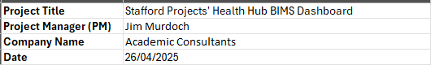**Pre Section:**

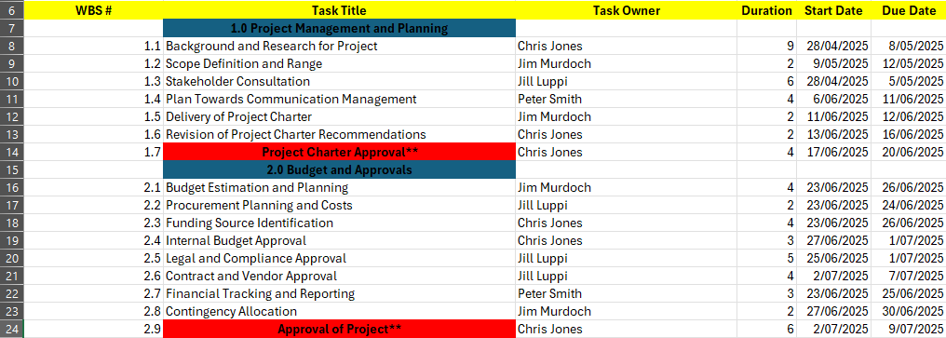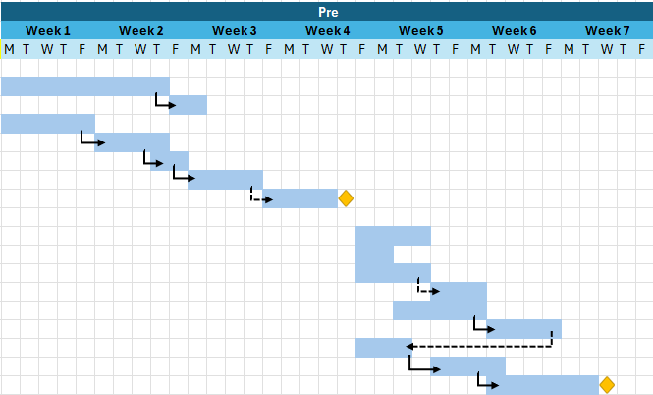

**During Section:**

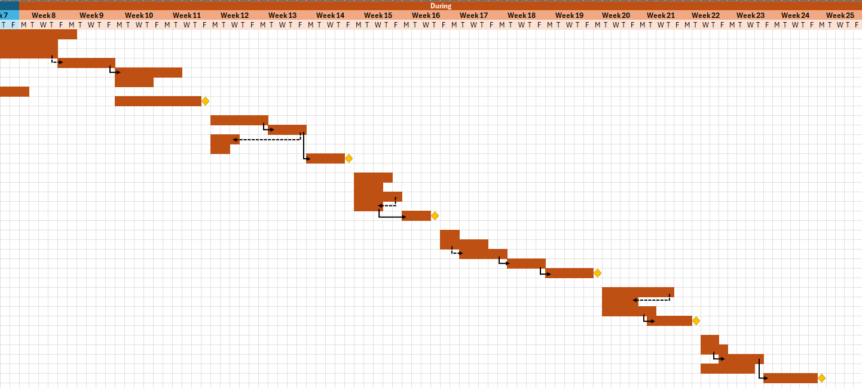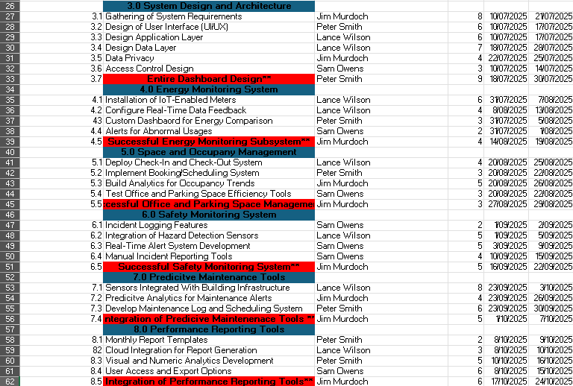

**Post Section:**

